**Student:** Oleksandr Romanchenko

**ID:** 83459

Analysis of autoregressive parameters and their impact to the presence of autocorrelation in the model

The data is the same as in homework 1. Dependent variable y – number of deaths, x – fertility rate.

SARAR:

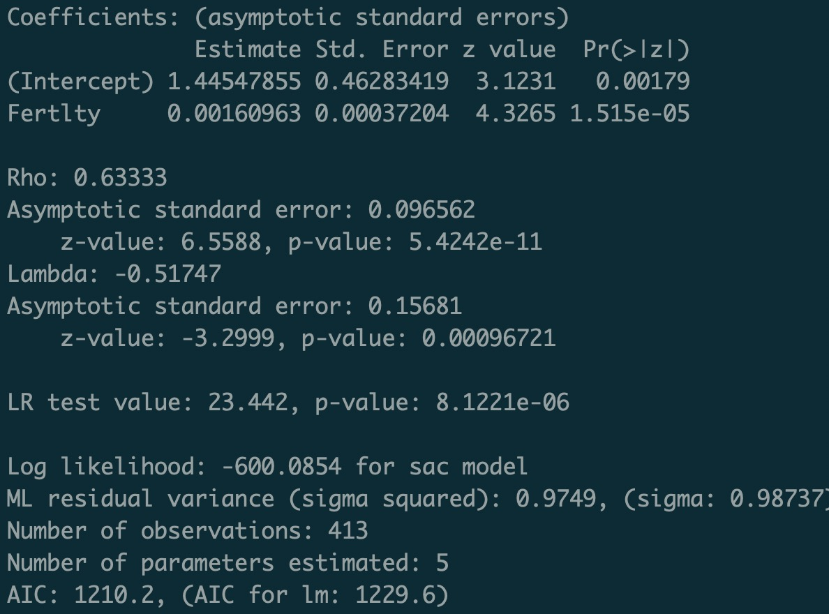

* p-value of independent variable is close to 0 meaning that variable is significant
* value of Rho (0.63333) tells that decent amount of causation comes from independent variable
* lambda value tells about negative autocorrelation of the error term
* LR test tells that inclusion of lagged value may improve the model
* AIC: 1210.2

SDM:

* p-value of independent variable is close to 0 meaning that variable is significant
* lag value is not significant
* value of Rho (0.25703) tells that only small amount of causation comes from independent variable
* LM test tells that there exists spatial autocorrelation
* AIC: 1214.2

SDEM:

* p-value of independent variable is close to 0 meaning that variable is significant
* in this case lag variable is significant
* lambda value tells about positive autocorrelation of the error term
* LR test tells that inclusion of lagged value may improve the model
* AIC: 1215.3

**Conclusion:** According to the output from models I think that SARAR best explains variables.

Both p-value of independent variable and Rho tell that x is significant and deals decent amount of causation. LR tells that included lagged value may improve the model which goes in line with what we see in SDEM model.

Also considering 3 AIC criteria:

1) 1210.2

2) 1214.2

3) 1215.3

AIC also tells that SARAR model is best.